**CHAROTAR UNIVERSITY OF SCIENCE & TECHNOLOGY**

FACULTY OF TECHNOLOGY AND ENGINEERING

**Devang Patel Institute of Advance Technology & Research**

Semester: IV

Academic year: 2019-20

**ASSIGNMENT-1**

**AIM:-** To install and understand the basic working of an Operating system such as UBUNTU .

**THEORY:- Ubuntu** is a free and open-source Linux distribution based on Debian.  Ubuntu is officially released in three editions: *Desktop*, *Server*, and *Core* (for internet of things devices and robots). All the editions can run on the computer alone, or in a virtual machine. Ubuntu is a popular operating system for cloud computing, with support for OpenStack.

Ubuntu is released every six months, with long-term support (LTS) releases every two years. The latest release is 19.10 ("Eoan Ermine"), and the most recent long-term support release is 18.04 LTS ("Bionic Beaver"), which is supported until 2023 under public support and until 2028 as a paid option. Ubuntu is developed by Canonical, and a community of other developers, under a meritocratic governance model. Canonical provides security updates and support for each Ubuntu release, starting from the release date and until the release reaches its designated end-of-life (EOL) date.Canonical generates revenue through the sale of premium services related to Ubuntu.

**QUESTIONS AND SOLUTIONS**

1. **Install the following Linux distribution and release on your own computer: Ubuntu. Desktop 64-bit 18.04 LTS. It is essential that you install this distribution and release so that you will not have problems like "was working on my machine". You can install Linux on bare hardware, i.e., on a partition of your hard-disk. In this case, make sure you first backup all your important data so that you will not loose your data in case your computer does not boot up after installation**

**SOLUTION:-** VM Ware is a software platform which provides facility to the user to install and run multiple operating system on a single device without dual booting the device. For the installation process of any operating system to the vmware software we need the iso (image) file of the respective operating system. We first download the iso file of Ubuntu Desktop 64-bit 18.04 LTS from the official website of ubuntu.

1. **Write briefly about your installation choices and experiences in your report. After installing Linux, start Linux and learn basic Linux usage. There are lots of guides and tutorials in Internet teaching basic Linux usage. You can benefit from them. In your report, write down the names of 10 Linux commands that you learned.**

**SOLUTION:-** Once we start the Vmware for the installation of the OS we need to select a new virtual machine as we are installing a new OS. At one stage we are asked to select the type and configuration of the operating system. Here we make necessary changes according to our system requirements . The number of core that need to be assigned to the running of operating system is 4. The machine needs 4 GB(4096 MB) of virtual memory. Then the rest of the options need no changes. At last when we click finish the virtual machine is created based on the entered preferences. The virtual machine needs 20 GB of physical memory from the device memory to run and save the data on the operating system. To turn the operating system ON the iso file needs to be inserted to the machine. This can be done from the “select ISO file” option in settings. Once this process is complete the virtual machine and Operating System both are ready to be turned ON.

The screenshots would make it clear,

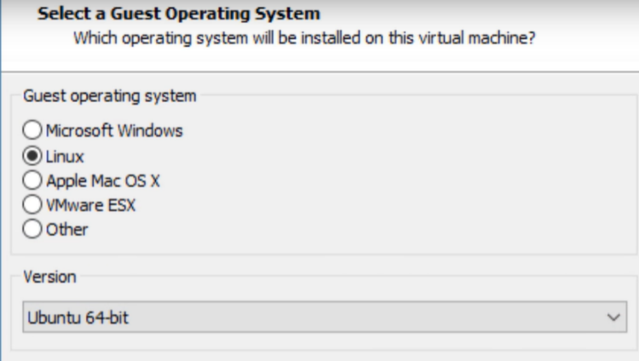

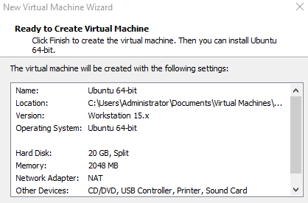

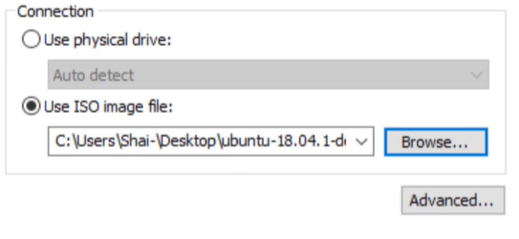

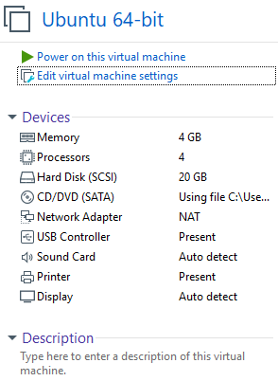

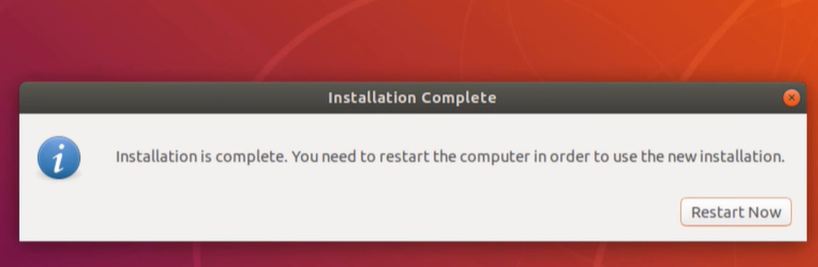

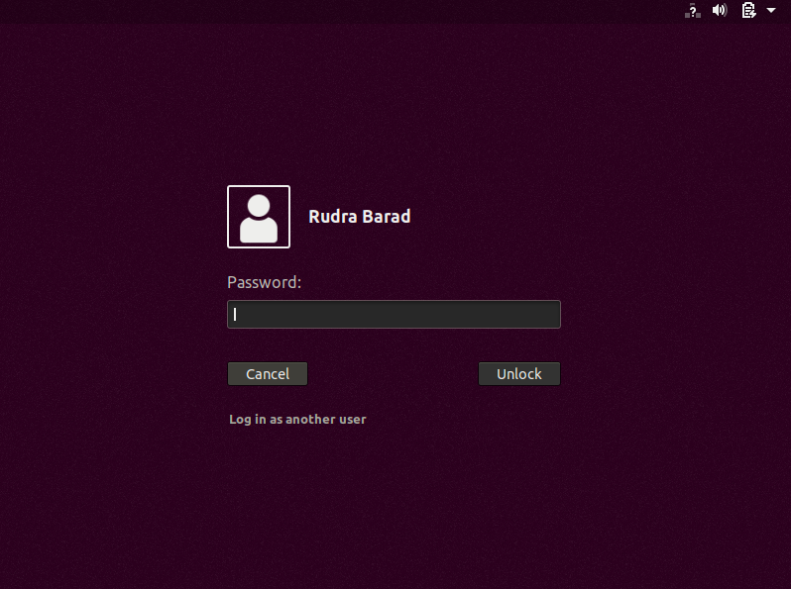

And that’s it the Ubuntu operating system is successfully installed on the device.

**Some of the basic commands that are used frequently in ubuntu are:-**

1. **Cp:-**“cp” command is used to copy file contents to another file.

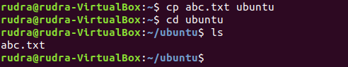

1. **Mv:-**The “mv” command is used to move files from one directory to another.

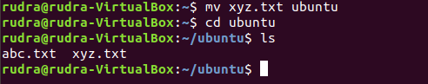

1. **Rm:-**The “rm” command is used to remove(delete) files.

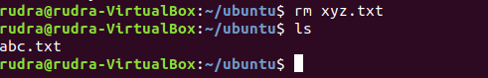

1. **Sort:-**The “sort” command is used to sort the data contents line wise in the file.

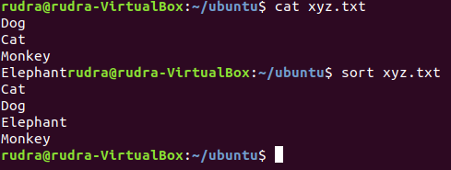

1. **Cat:-**“cat” command displays the file contents to on the output terminal.



1. **Pr:-**The “pr” command is used to display file details and its contents.

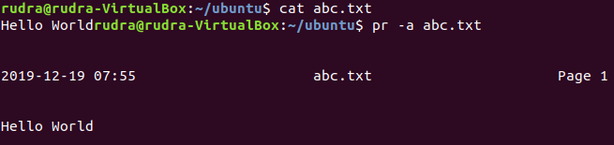

1. **File:-**“file” command returns the data type of the data stored in the file.



1. **Find:-** The “find” command returns path to each and every file and folder saved in the directory entered.

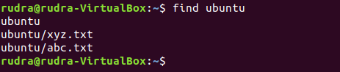

1. **More:-** “more” command is used to sort and display a particular section of the content from whole file.

**CMP**

1. **Cmp:-** When “cmp” is used for comparison between two files, it reports the location of the first mismatch to the screen if difference is found and if no difference is found i.e the files compared are identical.



1. **Find out and write down the location (pathname) where the kernel executable resides in the default directory tree (starting with “/ “) of your Linux installation. Find out the version of your running kernel by using the "uname -r" command. Write the version number in your report.**

**SOLUTION:-**The current kernel version of my linux operating system is 4.18.0-15-generic.The kernel version information can be gained by using the “uname -r” command in the terminal . The kernel executable resides in the Virtual_machine_name:/lib/modules (as I am using the virtual machine to run the operating system). And the kernel executable is located and saved with the name same as that of the name of kernel version.



Kernel version number: 5.0.0-23-generic

Kernel executable location-



1. **Download the source code of the Linux kernel (from kernel.org, for example). Download the version that is close to the version of your running kernel. After opening the tar package, change into the root directory of the downloaded kernel source code (it is in the directory where you downloaded the tar package), and in your report write the names of the subdirectories you see there**

**SOLUTION:-**The source code zip file for the linux kernel version 5.4.3 can be obtained from the official website of ubuntu for the kernel downloads. The zip file is named as “linux-5.4.3.tar.gz” by default. This file can be extracted using the “tar -xvf linux-5.4.3.tar.gz” command which is the linux supported command to unzip the zip files with ‘.gz’ extension.

The files in the zip file can be listed as shown in the following snapshot,

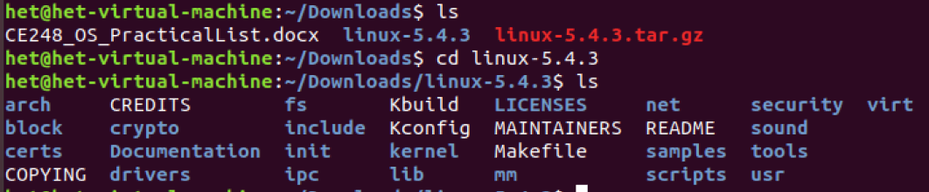

1. **In the source code of the kernel, find out the definition of the system call table. Write the pathname where you found it. Then, examine the table. Find out the system call names corresponding to system call numbers 5, 43, 123, and 220.**

**SOLUTION:-**The system call names corresponding to the given values are:-

System Call Name

5 newstat

43 accept

123 rt_sigpending

220 mq_open

The pathname for the syscall can be given as follows:-



1. **Use the strace command of Linux to trace the system calls made by some simple programs like cp, ls, etc. Use the manual page of strace to learn more about it (type man strace). Include sample output in your report. The “man” command provides help pages about Linux commands, system calls, and C library functions.**

**SOLUTION:-**Using the “strace” command returns the trace of the system calls made by basic programs in the program . The strace command can be used in different ways to get the different required outputs based on the necessary requirements. Some of the basic forms in which the “strace” command is used are:-

* + 1. **Strace df -h** :- You can simply run a command with **strace** like this, here we are tracing of all system calls made by the df command. This would just return the basic but necessary information (trace) about each and every instance where the “df ” command was used.
    2. **Strace ls:-**The given command returns the trace of system calls made by “ls” command.

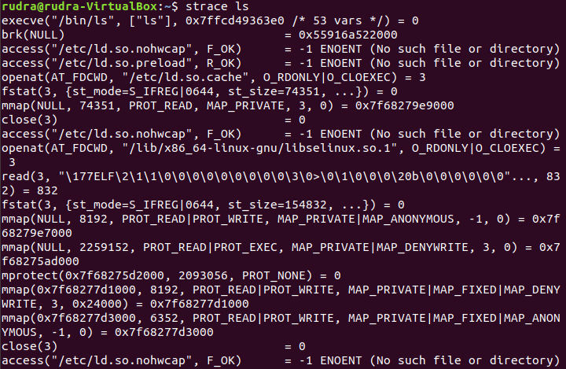

* + 1. 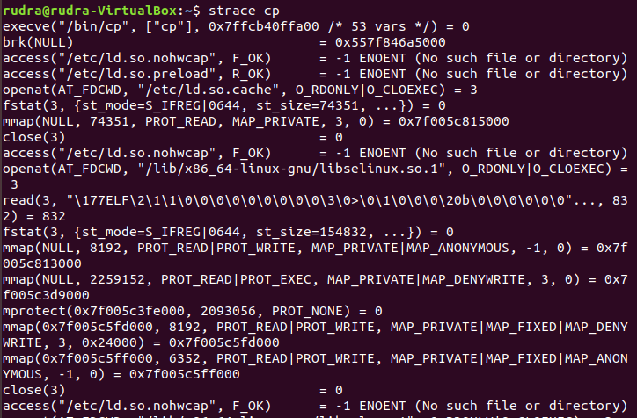**Strace cp:-** The given command returns the trace of system calls made by “cp” command.

1. **Use the time command to measure the time required to execute some programs like cp, etc. It reports different times: real, user and sys. What are they? Write those values for different program executions.**

**SOLUTION:-** Time command in Linux is used to execute a command and prints a summary of real-time, user CPU time and system CPU time spent by executing a command when it terminates. ‘real’ time is the time elapsed wall clock time taken by a command to get executed, while ‘user’and ‘sys’ time are the number of CPU seconds that command uses in user and kernel mode respectively.

The execution of time command for some program executions can be shown by the following snapshots:

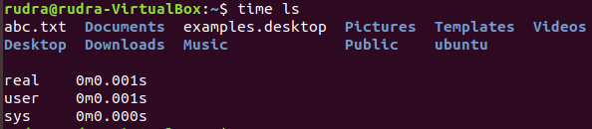

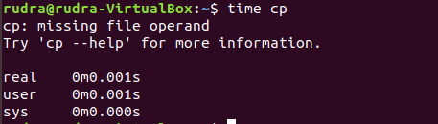

1. **Write a simple C program to compare the cost (in terms of elapsed time) of different system calls with different parameter values. Different system calls can be: getpid(), read(), write(), open(), mkdir(), etc. Different parameter values, for example for the read() system call, can be: read 100 bytes, 1000 bytes, 10000 bytes, or 100000 bytes into a buffer of enough size. You can call the program as cost.c. To get the current time in the program you can use the gettimeofday() system call. It gives the current time in microseconds granularity. You can call this before and after a system call is made to measure the elapsed time.**

**Write a simple Makefile to compile your program. A Makefile is a set of directives and commands specified in a file to compile a project. The following can be a starting point for your Makefile content. Be careful about TAB characters.**

all: cost

cost: cost.c

gcc –Wall –g -o cost cost.c

clean:

rm -fr cost cost.o *~

**PROGRAM CODE:-**

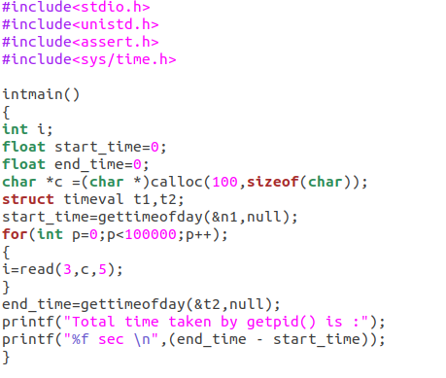

**OUTPUT:-**

